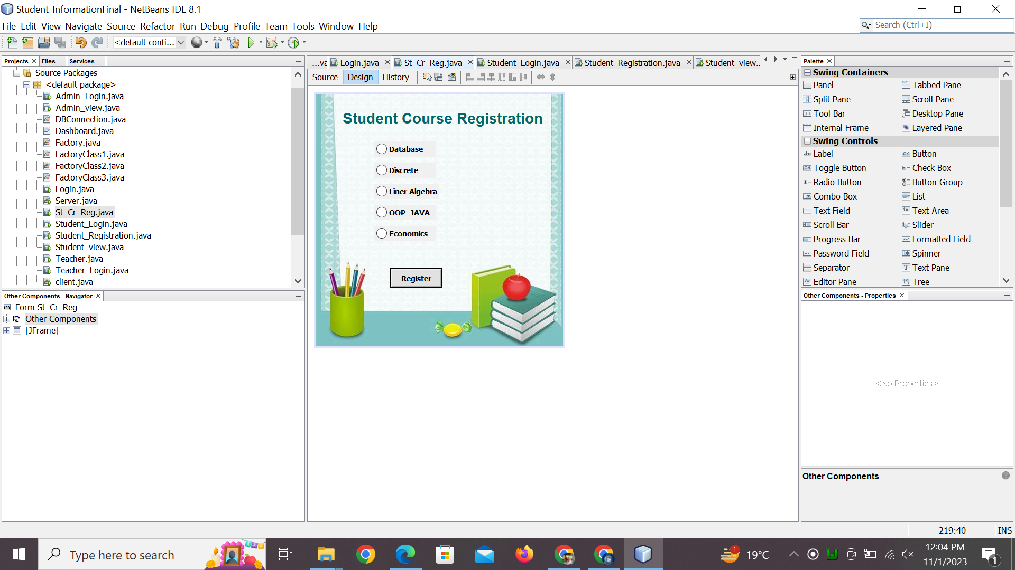

import java.sql.Connection;

import java.sql.ResultSet;

import java.sql.Statement;

import javax.swing.JOptionPane;

/*

* To change this license header, choose License Headers in Project Properties.

* To change this template file, choose Tools | Templates

* and open the template in the editor.

*/

/**

*

* @author Chaudhry Hammad

*/

public class St_Cr_Reg extends javax.swing.JFrame {

/**

* Creates new form St_Cr_Reg

*/

Connection con=DBConnection.getDBConnection();

String username,password;

public St_Cr_Reg() {

initComponents();

}

public St_Cr_Reg(String username,String password) {

initComponents();

this.username=username;

this.password=password;

JOptionPane.showMessageDialog(this,"Your username is "+username+" and Password is "+password);

}

/**

* This method is called from within the constructor to initialize the form.

* WARNING: Do NOT modify this code. The content of this method is always

* regenerated by the Form Editor.

*/

@SuppressWarnings("unchecked")

// <editor-fold defaultstate="collapsed" desc="Generated Code">

private void initComponents() {

jLabel1 = new javax.swing.JLabel();

databaserdbtn = new javax.swing.JRadioButton();

linearrdbtn = new javax.swing.JRadioButton();

economicsrdbtn = new javax.swing.JRadioButton();

discreterdbtn = new javax.swing.JRadioButton();

ooprdbtn = new javax.swing.JRadioButton();

registercoursebtn = new javax.swing.JButton();

jLabel3 = new javax.swing.JLabel();

jLabel2 = new javax.swing.JLabel();

setDefaultCloseOperation(javax.swing.WindowConstants.EXIT_ON_CLOSE);

setBackground(new java.awt.Color(0, 0, 0));

setForeground(java.awt.Color.black);

getContentPane().setLayout(new org.netbeans.lib.awtextra.AbsoluteLayout());

jLabel1.setFont(new java.awt.Font("Arial", 1, 28)); // NOI18N

jLabel1.setForeground(new java.awt.Color(0, 102, 102));

jLabel1.setHorizontalAlignment(javax.swing.SwingConstants.CENTER);

jLabel1.setText("Student Course Registration ");

getContentPane().add(jLabel1, new org.netbeans.lib.awtextra.AbsoluteConstraints(50, 30, -1, -1));

databaserdbtn.setFont(new java.awt.Font("Tahoma", 1, 14)); // NOI18N

databaserdbtn.setText("Database");

getContentPane().add(databaserdbtn, new org.netbeans.lib.awtextra.AbsoluteConstraints(110, 90, 117, -1));

linearrdbtn.setFont(new java.awt.Font("Tahoma", 1, 14)); // NOI18N

linearrdbtn.setText("Liner Algebra");

linearrdbtn.addActionListener(new java.awt.event.ActionListener() {

public void actionPerformed(java.awt.event.ActionEvent evt) {

linearrdbtnActionPerformed(evt);

}

});

getContentPane().add(linearrdbtn, new org.netbeans.lib.awtextra.AbsoluteConstraints(110, 170, -1, -1));

economicsrdbtn.setFont(new java.awt.Font("Tahoma", 1, 14)); // NOI18N

economicsrdbtn.setText("Economics");

getContentPane().add(economicsrdbtn, new org.netbeans.lib.awtextra.AbsoluteConstraints(110, 250, 117, -1));

discreterdbtn.setFont(new java.awt.Font("Tahoma", 1, 14)); // NOI18N

discreterdbtn.setText("Discrete");

getContentPane().add(discreterdbtn, new org.netbeans.lib.awtextra.AbsoluteConstraints(110, 130, 117, -1));

ooprdbtn.setFont(new java.awt.Font("Tahoma", 1, 14)); // NOI18N

ooprdbtn.setText("OOP_JAVA");

ooprdbtn.addActionListener(new java.awt.event.ActionListener() {

public void actionPerformed(java.awt.event.ActionEvent evt) {

ooprdbtnActionPerformed(evt);

}

});

getContentPane().add(ooprdbtn, new org.netbeans.lib.awtextra.AbsoluteConstraints(110, 210, 117, -1));

registercoursebtn.setFont(new java.awt.Font("Tahoma", 1, 14)); // NOI18N

registercoursebtn.setText("Register");

registercoursebtn.setBorder(javax.swing.BorderFactory.createMatteBorder(2, 2, 2, 2, new java.awt.Color(0, 0, 0)));

registercoursebtn.addActionListener(new java.awt.event.ActionListener() {

public void actionPerformed(java.awt.event.ActionEvent evt) {

registercoursebtnActionPerformed(evt);

}

});

getContentPane().add(registercoursebtn, new org.netbeans.lib.awtextra.AbsoluteConstraints(140, 330, 99, 38));

jLabel3.setIcon(new javax.swing.ImageIcon("C:\\Users\\USER\\Desktop\\pix\\h.jpeg")); // NOI18N

getContentPane().add(jLabel3, new org.netbeans.lib.awtextra.AbsoluteConstraints(0, -210, 470, 700));

jLabel2.setText("jLabel2");

getContentPane().add(jLabel2, new org.netbeans.lib.awtextra.AbsoluteConstraints(0, 0, 470, 480));

pack();

}// </editor-fold>

private void registercoursebtnActionPerformed(java.awt.event.ActionEvent evt) {

// TODO add your handling code here:

cr_reg();

}

public boolean cr_reg(){

try{

Statement stmt = con.createStatement();

String sql1="select id from student where username="+username+" ";

ResultSet rs=stmt.executeQuery(sql1);

if(rs.next()){

int id=rs.getInt("id");

if(databaserdbtn.isSelected()){

String sql3 = "insert into student_course(st_cr_id,cr_st_id) " + "values ("+id+",'"+111+"') ";

stmt.executeUpdate(sql3);

}

if(discreterdbtn.isSelected()){

String sql4 = "insert into student_course(st_cr_id,cr_st_id) " + "values ("+id+",'"+222+"') ";

stmt.executeUpdate(sql4);

}

if(linearrdbtn.isSelected()){

String sql5 = "insert into student_course(st_cr_id,cr_st_id) " + "values ("+id+",'"+333+"') ";

stmt.executeUpdate(sql5);

}

if(ooprdbtn.isSelected()){

String sql6 = "insert into student_course(st_cr_id,cr_st_id) " + "values ("+id+",'"+444+"') ";

stmt.executeUpdate(sql6);

}

if(economicsrdbtn.isSelected()){

String sql7 = "insert into student_course(st_cr_id,cr_st_id) " + "values ("+id+",'"+555+"') ";

stmt.executeUpdate(sql7);

}

JOptionPane.showMessageDialog(null, "Courses registered successfull");

Student_Login studentlogin=new Student_Login();

studentlogin.setVisible(true);

setVisible(false);

dispose();

}

con.close();

return true;

}

catch(Exception e){

System.out.println(e);

return false;

}

// Student_Login studentlogin=new Student_Login();

// studentlogin.setVisible(true);

//

// setVisible(false);

// dispose();

}

private void ooprdbtnActionPerformed(java.awt.event.ActionEvent evt) {

// TODO add your handling code here:

}

private void linearrdbtnActionPerformed(java.awt.event.ActionEvent evt) {

// TODO add your handling code here:

}

/**

* @param args the command line arguments

*/

public static void main(String args[]) {

/* Set the Nimbus look and feel */

//<editor-fold defaultstate="collapsed" desc=" Look and feel setting code (optional) ">

/* If Nimbus (introduced in Java SE 6) is not available, stay with the default look and feel.

* For details see http://download.oracle.com/javase/tutorial/uiswing/lookandfeel/plaf.html

*/

try {

for (javax.swing.UIManager.LookAndFeelInfo info : javax.swing.UIManager.getInstalledLookAndFeels()) {

if ("Nimbus".equals(info.getName())) {

javax.swing.UIManager.setLookAndFeel(info.getClassName());

break;

}

}

} catch (ClassNotFoundException ex) {

java.util.logging.Logger.getLogger(St_Cr_Reg.class.getName()).log(java.util.logging.Level.SEVERE, null, ex);

} catch (InstantiationException ex) {

java.util.logging.Logger.getLogger(St_Cr_Reg.class.getName()).log(java.util.logging.Level.SEVERE, null, ex);

} catch (IllegalAccessException ex) {

java.util.logging.Logger.getLogger(St_Cr_Reg.class.getName()).log(java.util.logging.Level.SEVERE, null, ex);

} catch (javax.swing.UnsupportedLookAndFeelException ex) {

java.util.logging.Logger.getLogger(St_Cr_Reg.class.getName()).log(java.util.logging.Level.SEVERE, null, ex);

}

//</editor-fold>

/* Create and display the form */

java.awt.EventQueue.invokeLater(new Runnable() {

public void run() {

new St_Cr_Reg().setVisible(true);

}

});

}

// Variables declaration - do not modify

private javax.swing.JRadioButton databaserdbtn;

private javax.swing.JRadioButton discreterdbtn;

private javax.swing.JRadioButton economicsrdbtn;

private javax.swing.JLabel jLabel1;

private javax.swing.JLabel jLabel2;

private javax.swing.JLabel jLabel3;

private javax.swing.JRadioButton linearrdbtn;

private javax.swing.JRadioButton ooprdbtn;

private javax.swing.JButton registercoursebtn;

// End of variables declaration

}